COMP330 Assignment 1 Report

**Name**:

**Student ID**:

Features implemented in this assignment:

|  |  |  |
| --- | --- | --- |
| **Feature** | **Mark** | **Check if used** |
| Height map modelling | 20% | X |
| Trees | 5% | X |
| Textured terrain | 10% |  |
| Multiple textures | 5% |  |
| Player movement (simple) | 10% |  |
| Player movement (complex) | 15% | X |
| First-person perspective camera | 10% | X |
| + zoom | 5% | X |
| Third person orthographic camera | 10% | x |
| + zoom | 5% | x |
| Directional light | 5% | x |
| Point light | 5% |  |
| Smooth shading | 10% | x |
| Screen-space effects | 5% |  |
| Transparency | 5% |  |
| **TOTAL** (max 100%) |  | %85 |

On the following pages you should indicate where each of the above features appear in your game, using screenshots and filenames/line-numbers to indicate where it occurs in your project.

You will not get marks for a feature if your marker cannot easily locate it within your world.

## Heightmap Terrain

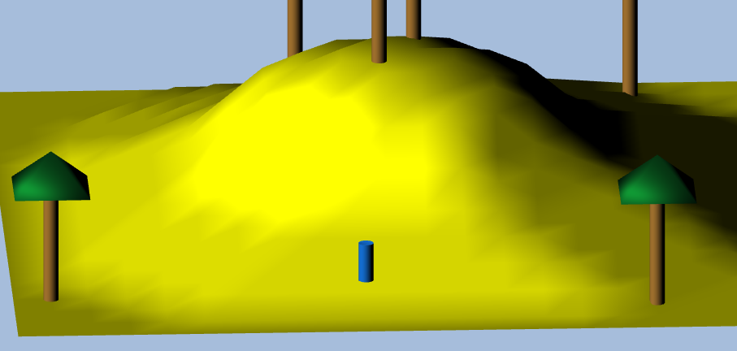

Implemented in:

* plane.js:1-105 – initialisation and render code for heightmap
* main.js:147-170 – generate coordinates for heightmap points
* main.js:624 – render heightmap

## Trees

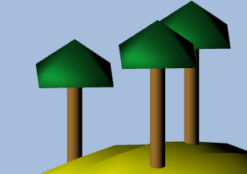

Implemented in:

* tree.js:1-105 – initialisation and render code for trees
* main.js:180-121 – generate coordinates for tree points
* main.js:626-231 – render trees

## Complex Player Movement

Implemented in:

* main.js:287-427 – code for controls

## First Person Perspective Camera

Implemented in:

* main.js:525-577 – setting camera position and target
* main.js:462-478 – switch between cameras
* main.js:480-499 - zoom

## Third Person Orthographic Camera

Implemented in:

* main.js:571-612 – setting camera position and target
* main.js:462-478 – switch between cameras
* main.js:480-499 – zoom

## Directional Light

Implemented in:

* main.js:560-569 – setting light values

## Smooth Shading

Implemented in:

* tree.js:83-109 – average of face normals for each vertex for branch
* tree.js:208-234 – average of face normals for each vertex for trunk
* plane.js:50-71 – average of face normals for each vertex for heightmap
* player.js:108-129 – average of face normal for each vertex for player